**Lab Assignment in Artificial Intelligence and Machine Learning Laboratory (OMC309)**

* **🚀 Author: 𝓓𝓮𝓮𝓹𝓪𝓷𝓴𝓪𝓻 𝓢𝓱𝓪𝓻𝓶𝓪**
* **🔍 ID: 233512013**
* **📧 Email:**[**233512013@geu.ac.in**](mailto:233512013@geu.ac.in)
* **🌐 GitHub Repository:**[**𝕄ℂ𝔸**](https://github.com/ideepankarsharma2003/MCA/)
* **📅 Year: 2023-2025**

**Exercise 1: Familiarization with the Python Programming Language**

**c. Python Program Code:**

*def* familiarize():

    # Basic Python Program

    # Print a message

    print("Hello, Python World!")

    # Variables and Data Types

    num = 10

    text = "Python"

    flt = 3.14

    print(*f*"Integer: {num}, String: {text}, Float: {flt}")

    # Control Structures

    # If-Else

    if num > 5:

        print(*f*"{num} is greater than 5")

    else:

        print(*f*"{num} is less than or equal to 5")

    # Loops

    print("Squares of numbers from 1 to 5:")

    for i in range(1, 6):

        print(*f*"{i}^2 = {i**2}")

    # Functions

*def* factorial(*n*):

        if *n* == 0 or *n* == 1:

            return 1

        return *n* * factorial(*n* - 1)

    print(*f*"Factorial of 5: {factorial(5)}")

    # Exception Handling

    try:

        division = num / 0

    except ZeroDivisionError:

        print("Division by zero is not allowed.")

    # Lists and Dictionary

    fruits = ["Apple", "Banana", "Cherry"]

    ages = {"Alice": 25, "Bob": 30, "Charlie": 35}

    print("Fruits List:", fruits)

    print("Ages Dictionary:", ages)

    # List Comprehension

    squares = [x**2 for x in range(1, 6)]

    print("List of Squares using List Comprehension:", squares)

familiarize()

**d. Sample Results:**

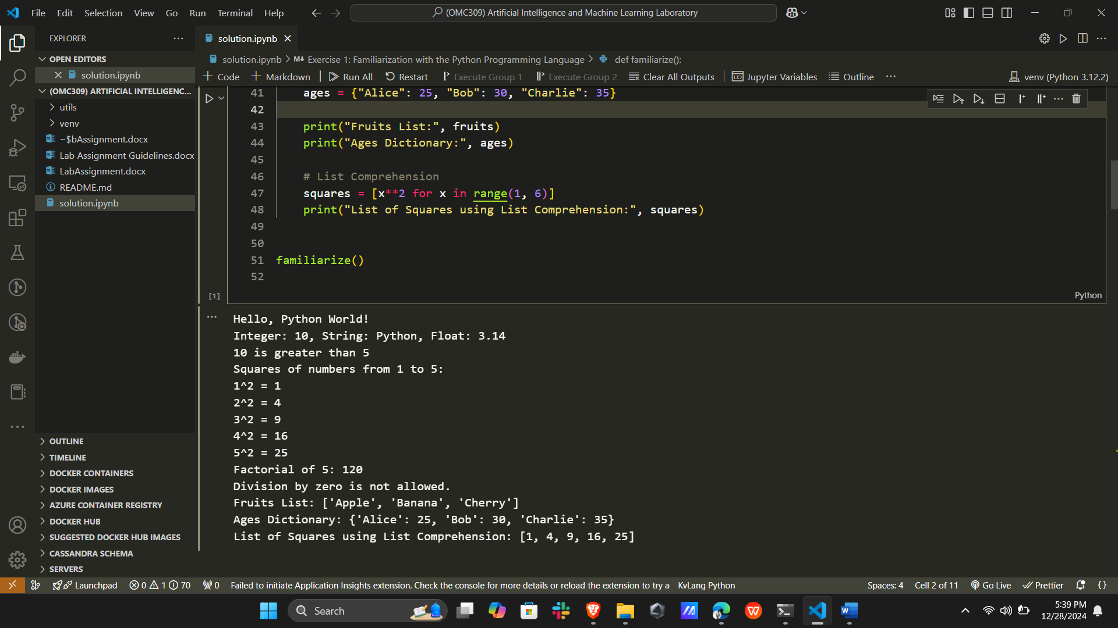

**e. Conclusion:**

This exercise provided a basic understanding of Python programming constructs, including variables, loops, conditionals, functions, and exception handling. It serves as a foundation for further exploration of Python's capabilities.

**Exercise 2. Development of a Simple Calculator (Part A)**

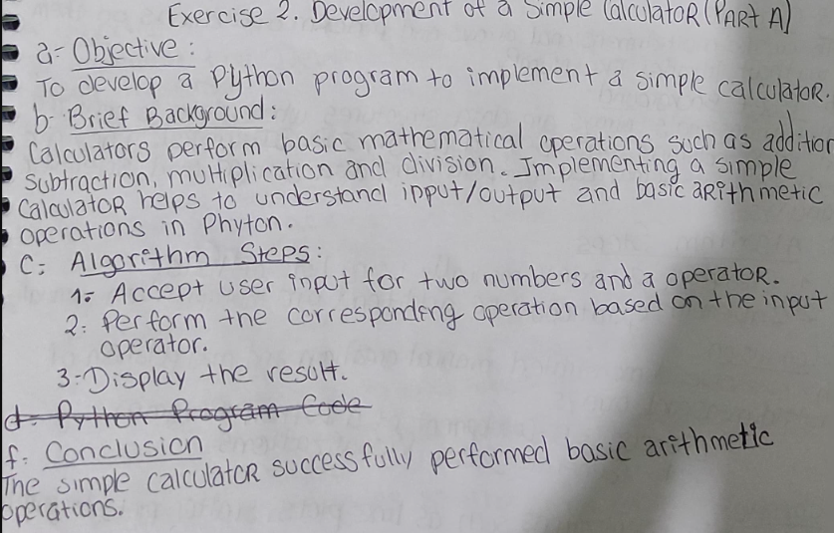**d. Python Program Code:**

*def* calculator(*a*, *b*, *operator*):

    if *operator* == '+':

        return *a* + *b*

    elif *operator* == '-':

        return *a* - *b*

    elif *operator* == '*':

        return *a* * *b*

    elif *operator* == '/':

        return *a* / *b* if *b* != 0 else "Division by zero not allowed"

    else:

        return "Invalid operator"

print('4 + 2 is ', calculator(4, 2, '+'))

print('4 - 2 is ', calculator(4, 2, '-'))

print('4 * 2 is ', calculator(4, 2, '*'))

print('4 / 2 is ', calculator(4, 2, '/'))

print('4 / 0 : ', calculator(4, 0, '/'))

**e. Sample Results:**

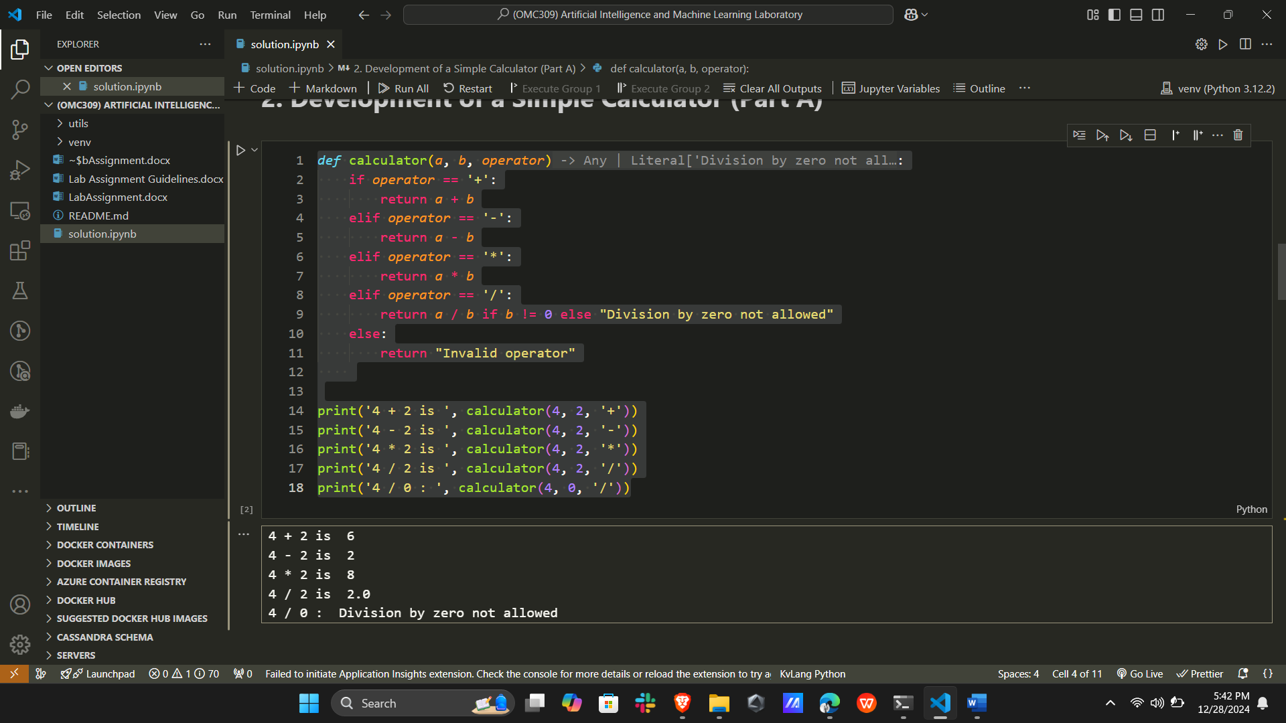

**f. Conclusion:**

The simple calculator successfully performed basic arithmetic operations.

**Exercise 2B: Development of a Python Program to Perform Operations on String, Set, Tuple Data Types, and Bitwise Operations**

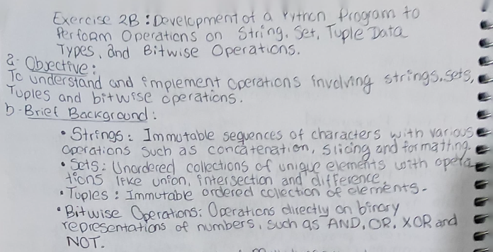**c. Python Program Code:**

# String Operations

string1 = "Hello"

string2 = "World"

concat = string1 + " " + string2

slice_str = string1[:3]

formatted = *f*"{string1}, {string2}!"

# Set Operations

set1 = {1, 2, 3}

set2 = {3, 4, 5}

union = set1 | set2

intersection = set1 & set2

difference = set1 - set2

# Tuple Operations

tuple1 = (1, 2, 3)

tuple2 = (4, 5, 6)

concat_tuple = tuple1 + tuple2

slice_tuple = tuple1[:2]

# Bitwise Operations

a, b = 5, 3  # Binary: 5 = 101, 3 = 011

bitwise_and = a & b  # 101 & 011 = 001

bitwise_or = a | b   # 101 | 011 = 111

bitwise_xor = a ^ b  # 101 ^ 011 = 110

bitwise_not = ~a     # ~101 = -110

# Output Results

print("String Operations:")

print(*f*"Concatenation: {concat}")

print(*f*"Slicing: {slice_str}")

print(*f*"Formatted: {formatted}\n")

print("Set Operations:")

print(*f*"Union: {union}")

print(*f*"Intersection: {intersection}")

print(*f*"Difference: {difference}\n")

print("Tuple Operations:")

print(*f*"Concatenation: {concat_tuple}")

print(*f*"Slicing: {slice_tuple}\n")

print("Bitwise Operations:")

print(*f*"AND: {bitwise_and}")

print(*f*"OR: {bitwise_or}")

print(*f*"XOR: {bitwise_xor}")

print(*f*"NOT: {bitwise_not}")

**e. Sample Results:**

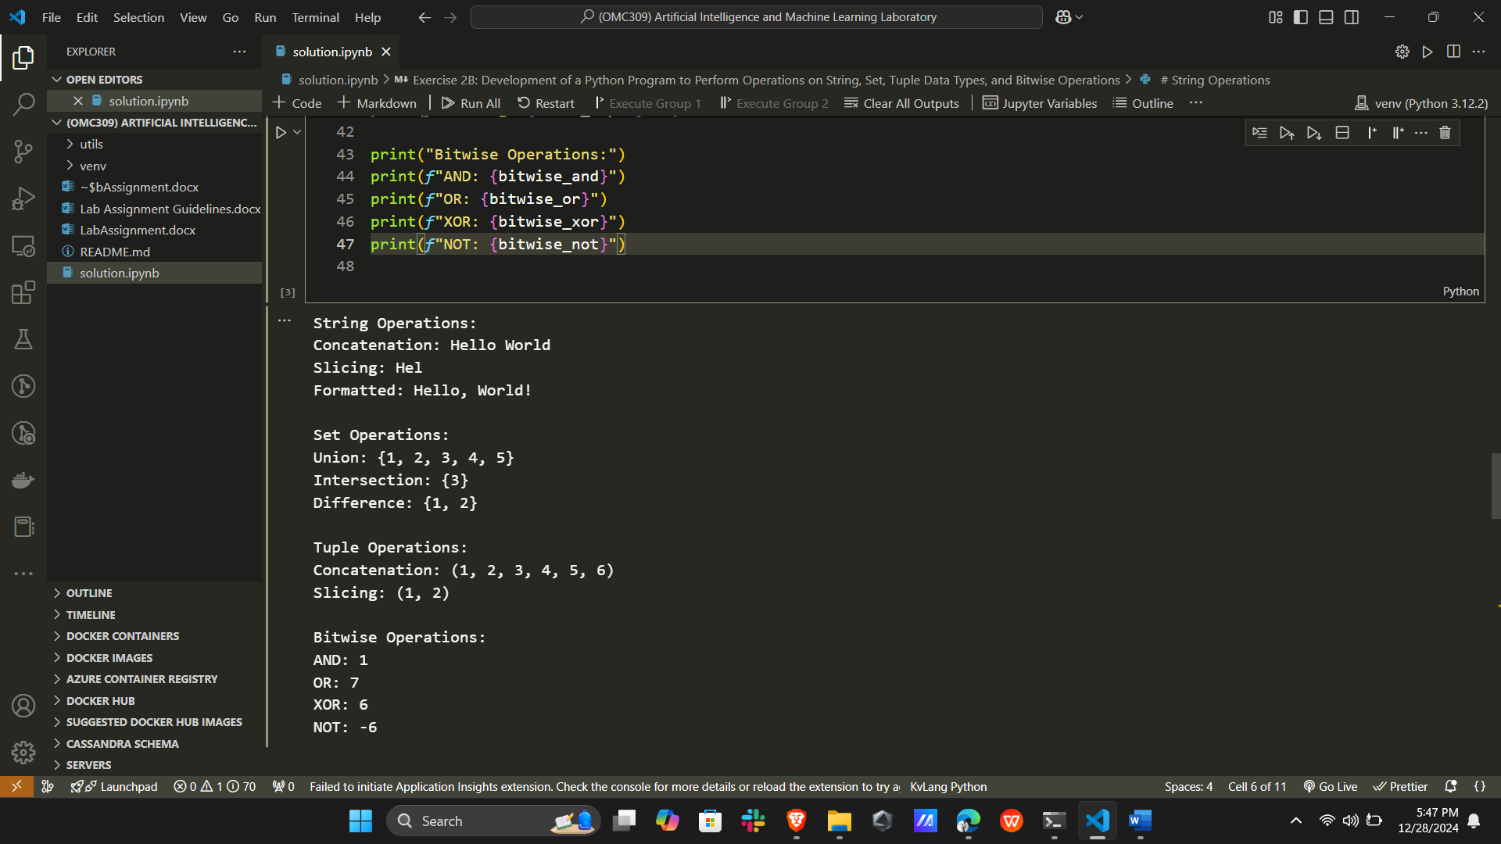

**Exercise 3. Development of Multidimensional Data Arrays (Part A)**

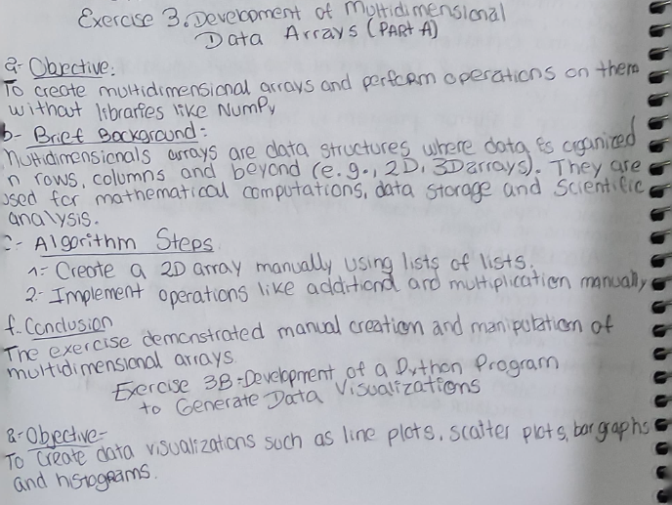**d. Python Program Code:**

# Creating a 2D array

matrix1 = [[1, 2], [3, 4]]

matrix2 = [[5, 6], [7, 8]]

# Adding two matrices

result_addition = [[matrix1[i][j] + matrix2[i][j]

                    for j in range(len(matrix1[0]))] for i in range(len(matrix1))]

# Multiplying two matrices

result_multiplication = [[sum(matrix1[i][k] * matrix2[k][j] for k in range(len(matrix1)))

                          for j in range(len(matrix2[0]))] for i in range(len(matrix1))]

# Output

print("Addition of matrices:", result_addition)

print("Multiplication of matrices:", result_multiplication)

**e. Sample Results:**

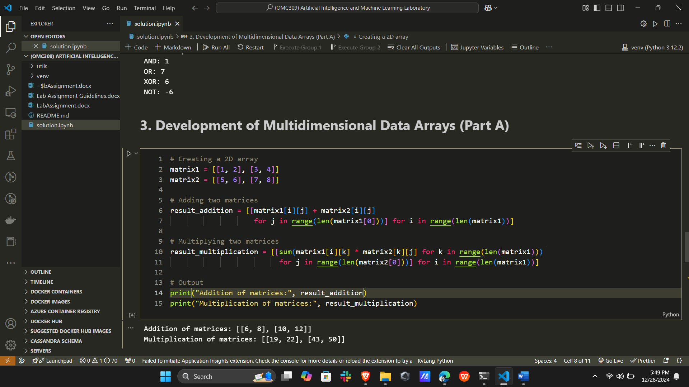

**f. Conclusion:**

The exercise demonstrated manual creation and manipulation of multidimensional arrays.

**Exercise 3B: Development of a Python Program to Generate Data Visualizations**

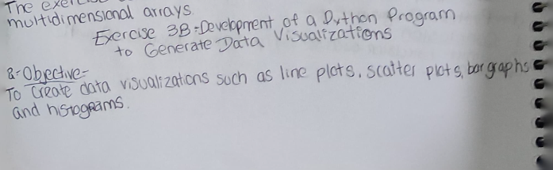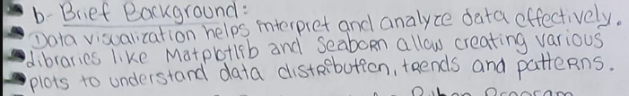

**c. Python Program Code:**

import matplotlib.pyplot as plt

import numpy as np

# Generate Data

x = np.linspace(0, 10, 100)

y = np.sin(x)

categories = ['A', 'B', 'C', 'D']

values = [5, 7, 3, 8]

data = np.random.randn(1000)

# Line Plot

plt.figure()

plt.plot(x, y, *label*="y = sin(x)")

plt.title("Line Plot")

plt.xlabel("x")

plt.ylabel("y")

plt.legend()

plt.show()

# Scatter Plot

plt.figure()

plt.scatter(x, np.cos(x), *c*='r', *label*="y = cos(x)")

plt.title("Scatter Plot")

plt.xlabel("x")

plt.ylabel("y")

plt.legend()

plt.show()

# Bar Graph

plt.figure()

plt.bar(categories, values, *color*='g')

plt.title("Bar Graph")

plt.xlabel("Category")

plt.ylabel("Values")

plt.show()

# Histogram

plt.figure()

plt.hist(data, *bins*=30, *alpha*=0.7, *color*='b')

plt.title("Histogram")

plt.xlabel("Value")

plt.ylabel("Frequency")

plt.show()

**e. Sample Results:**

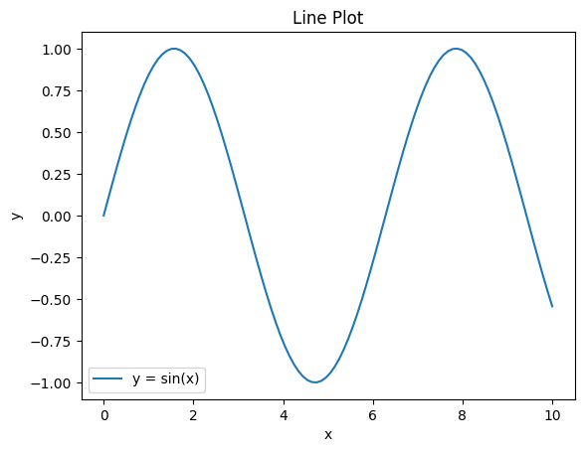  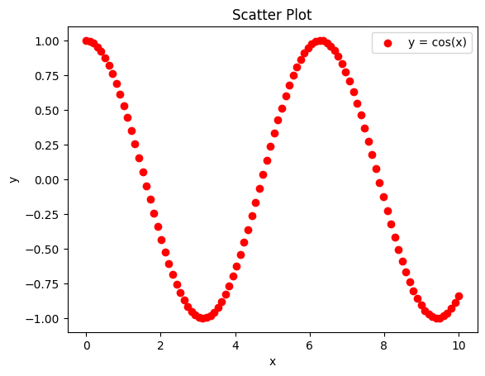

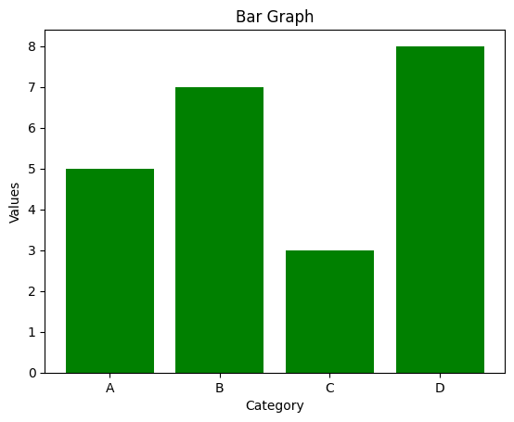 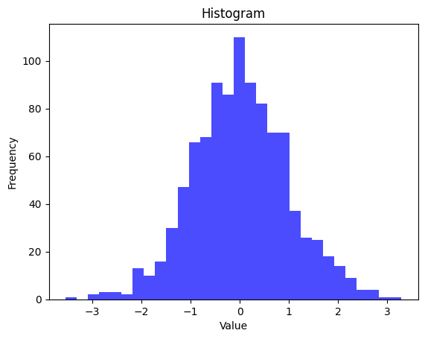

**Exercise 3C: Development of a Python Program to Perform Basic Scientific Operations Using the SciPy Library**



**c. Python Program Code:**

from scipy import optimize, integrate

import numpy as np

# Optimization Example: Minimize the quadratic function f(x) = (x-3)^2

*def* quadratic(*x*):

    return (*x* - 3)**2

result = optimize.minimize(quadratic, *x0*=0)

print("Optimization Result:")

print(*f*"Minimum Value: {result.fun} at x = {result.x[0]}\n")

# Integration Example: Integrate f(x) = x^2 from 0 to 5

*def* func(*x*):

    return *x*\*\*2

integration_result, _ = integrate.quad(func, 0, 5)

print("Integration Result:")

print(*f*"Integral of f(x) = x^2 from 0 to 5: {integration_result}\n")

# Solving Linear Equations Example: Solve Ax = b

A = np.array([[3, 2], [1, 4]])

b = np.array([5, 6])

x = np.linalg.solve(A, b)

print("Linear Equation Solution:")

print(*f*"Solution of Ax = b: x = {x}")

**e. Sample Results:**

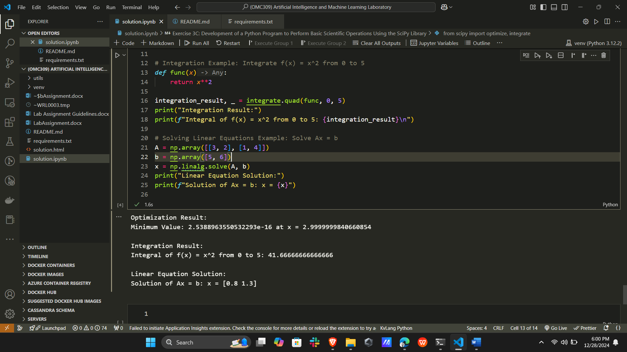

**4A. Python Implementation of the DFS Algorithm**

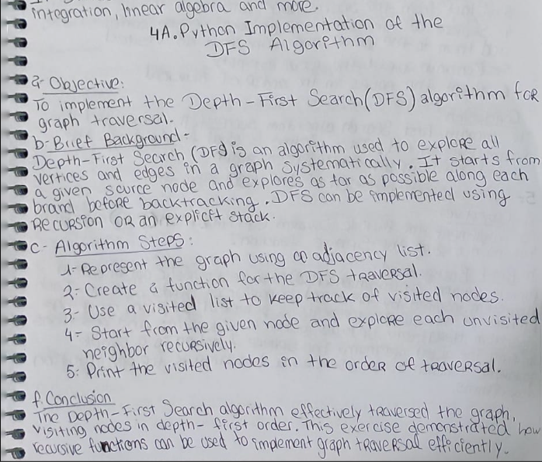**d. Python Program Code:**

# DFS Implementation

*def* dfs(*graph*, *start*, *visited*=None):

    if *visited* is None:

*visited* = set()

*visited*.add(*start*)

    print(*start*, *end*=" ")  # Print the node as it is visited

    for neighbor in *graph*[*start*]:

        if neighbor not in *visited*:

            dfs(*graph*, neighbor, *visited*)

# Define a graph as an adjacency list

graph = {

    'A': ['B', 'C'],

    'B': ['D', 'E'],

    'C': ['F'],

    'D': [],

    'E': ['F'],

    'F': []

}

# Perform DFS

print("DFS Traversal:")

dfs(graph, 'A')

**e. Sample Results:**

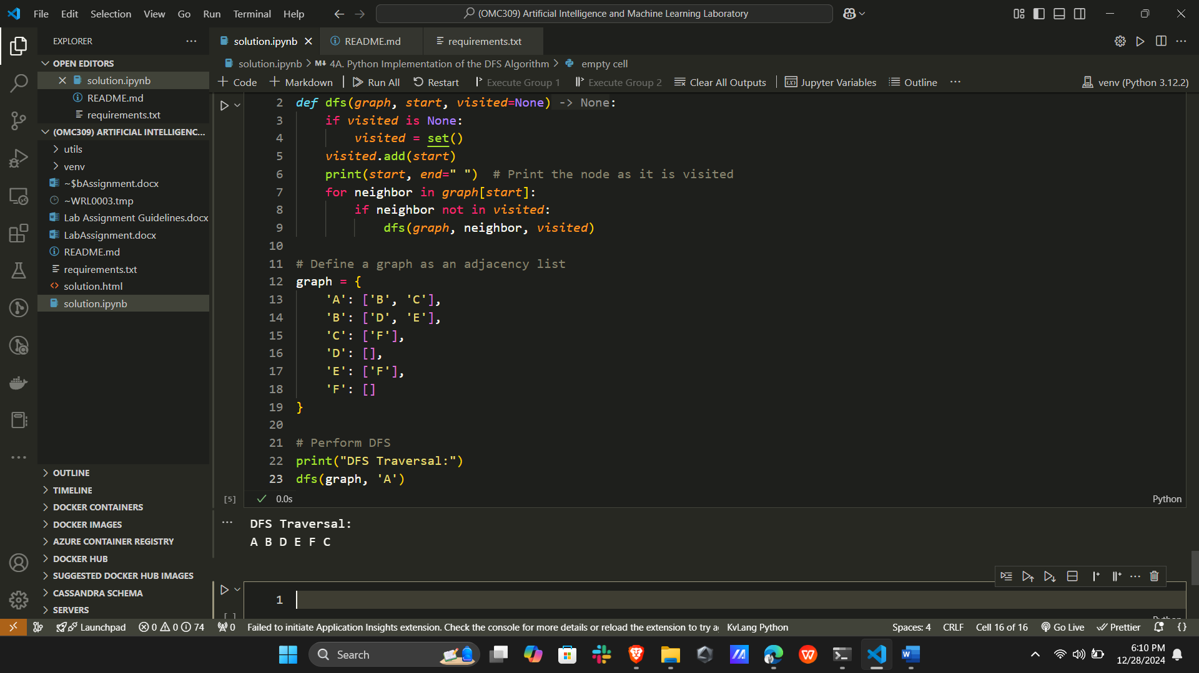

**f. Conclusion:**

The Depth-First Search algorithm effectively traversed the graph, visiting nodes in depth-first order. This exercise demonstrated how recursive functions can be used to implement graph traversal efficiently.

**4B. Python Implementation of the BFS Algorithm**

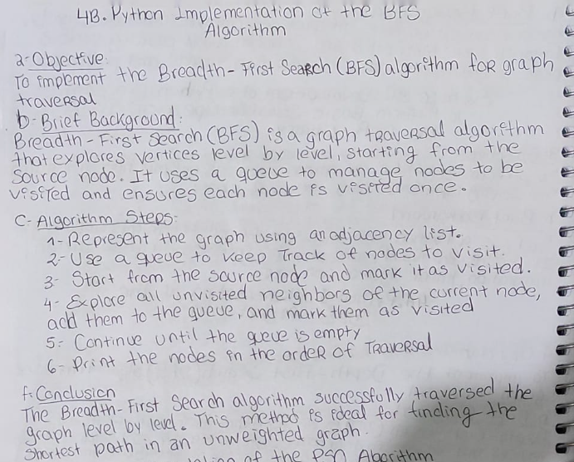

**d. Python Program Code:**

# BFS Implementation

from collections import deque

*def* bfs(*graph*, *start*):

    visited = set()

    queue = deque([*start*])

    visited.add(*start*)

    while queue:

        node = queue.popleft()

        print(node, *end*=" ")  # Print the node as it is visited

        for neighbor in *graph*[node]:

            if neighbor not in visited:

                visited.add(neighbor)

                queue.append(neighbor)

# Define a graph as an adjacency list

graph = {

    'A': ['B', 'C'],

    'B': ['D', 'E'],

    'C': ['F'],

    'D': [],

    'E': ['F'],

    'F': []

}

# Perform BFS

print("BFS Traversal:")

bfs(graph, 'A')

**e. Sample Results:**

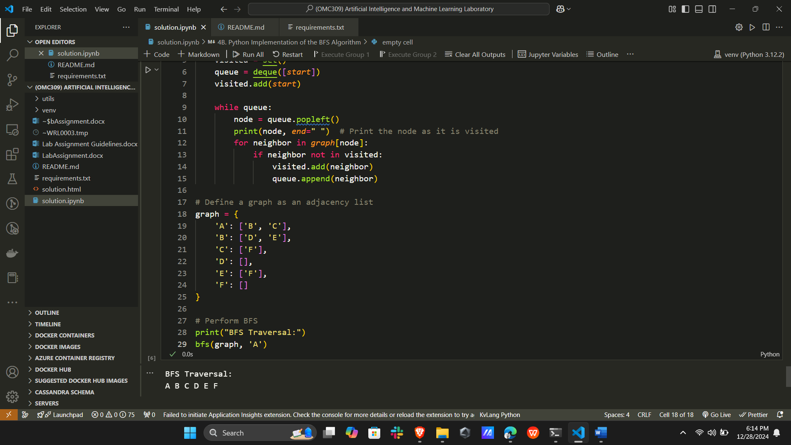

**f. Conclusion:**

The Breadth-First Search algorithm successfully traversed the graph level by level. This method is ideal for finding the shortest path in an unweighted graph.

**5. Python Implementation of the PSO Algorithm**

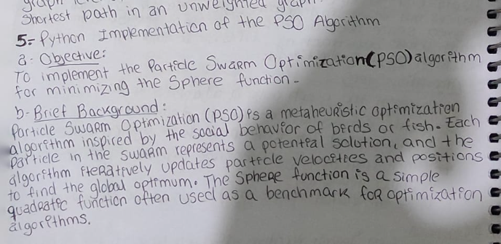**d.**

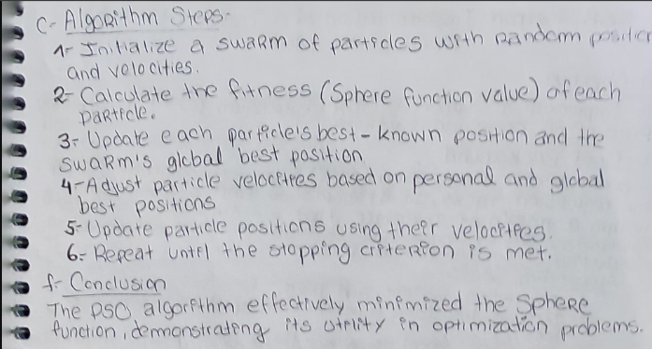

**d. Python Program Code:**

import random

# Sphere function

*def* sphere_function(*position*):

    return sum(x**2 for x in *position*)

# PSO Algorithm

*def* pso(*num_particles*, *dimensions*, *iterations*):

    # Initialize particles

    particles = [([random.uniform(-10, 10) for _ in range(*dimensions*)],  # Position

                  [random.uniform(-1, 1) for _ in range(*dimensions*)])    # Velocity

                 for _ in range(*num_particles*)]

    personal_best_positions = [p[0] for p in particles]

    personal_best_scores = [sphere_function(p[0]) for p in particles]

    global_best_position = min(personal_best_positions, *key*=sphere_function)

    global_best_score = sphere_function(global_best_position)

    # PSO parameters

    inertia = 0.5

    cognitive = 1.5

    social = 2.0

    for _ in range(*iterations*):

        for i, (position, velocity) in enumerate(particles):

            # Update velocities

            new_velocity = [

                inertia * velocity[d] +

                cognitive * random.random() * (personal_best_positions[i][d] - position[d]) +

                social * random.random() * (global_best_position[d] - position[d])

                for d in range(*dimensions*)

            ]

            # Update positions

            new_position = [position[d] + new_velocity[d] for d in range(*dimensions*)]

            # Update particle

            particles[i] = (new_position, new_velocity)

            # Update personal best

            current_score = sphere_function(new_position)

            if current_score < personal_best_scores[i]:

                personal_best_positions[i] = new_position

                personal_best_scores[i] = current_score

        # Update global best

        best_particle = min(particles, *key*=*lambda* *p*: sphere_function(*p*[0]))

        best_score = sphere_function(best_particle[0])

        if best_score < global_best_score:

            global_best_position = best_particle[0]

            global_best_score = best_score

    return global_best_position, global_best_score

# Run PSO

best_position, best_score = pso(*num_particles*=10, *dimensions*=2, *iterations*=50)

print(*f*"Best Position: {best_position}")

print(*f*"Best Score: {best_score}")

**e. Sample Results:**

Best Position: [-9.595962211031236e-07, 4.624109735013912e-06]

Best Score: 2.2303215749005826e-11

**f. Conclusion:**

The PSO algorithm effectively minimized the Sphere function, demonstrating its utility in optimization problems.

**6A. Python Implementation of a Support Vector Classifier**

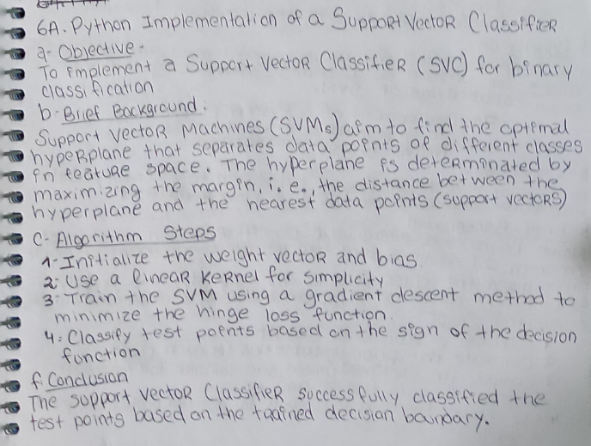

**d. Python Program Code:**

import numpy as np

import matplotlib.pyplot as plt

# Define the Support Vector Classifier class

*class* SupportVectorClassifier:

*def* __init__(*self*, *learning_rate*=0.001, *lambda_param*=0.01, *n_iters*=1000):

*self*.lr = *learning_rate*

*self*.lambda_param = *lambda_param*

*self*.n_iters = *n_iters*

*self*.w = None

*self*.b = None

*def* fit(*self*, *X*, *y*):

        n_samples, n_features = *X*.shape

        y_ = np.where(*y* <= 0, -1, 1)  # Convert to -1, 1

*self*.w = np.zeros(n_features)

*self*.b = 0

        for _ in range(*self*.n_iters):

            for idx, x_i in enumerate(*X*):

                condition = y_[idx] * (np.dot(x_i, *self*.w) + *self*.b) >= 1

                if condition:

*self*.w -= *self*.lr * (2 * *self*.lambda_param * *self*.w)

                else:

*self*.w -= *self*.lr * (2 * *self*.lambda_param * *self*.w - np.dot(x_i, y_[idx]))

*self*.b -= *self*.lr * y_[idx]

*def* predict(*self*, *X*):

        approx = np.dot(*X*, *self*.w) + *self*.b

        return np.sign(approx)

# Generate a larger dataset (200 samples)

np.random.seed(42)

# Class 1 (Positive, Label: 1)

X1 = np.random.normal(*loc*=[2, 2], *scale*=0.8, *size*=(100, 2))

y1 = np.ones(100)

# Class 2 (Negative, Label: -1)

X2 = np.random.normal(*loc*=[4, 4], *scale*=0.8, *size*=(100, 2))

y2 = -np.ones(100)

# Combine the datasets

X_train = np.vstack((X1, X2))

y_train = np.hstack((y1, y2))

# Train SVC

svc = SupportVectorClassifier()

svc.fit(X_train, y_train)

# Visualizing the dataset and decision boundary

plt.figure(*figsize*=(8, 6))

# Plot data points

plt.scatter(X1[:, 0], X1[:, 1], *color*='blue', *label*='Class 1 (1)')

plt.scatter(X2[:, 0], X2[:, 1], *color*='red', *label*='Class 2 (-1)')

# Create a mesh grid for decision boundary

x_min, x_max = X_train[:, 0].min() - 1, X_train[:, 0].max() + 1

y_min, y_max = X_train[:, 1].min() - 1, X_train[:, 1].max() + 1

xx, yy = np.meshgrid(np.linspace(x_min, x_max, 100), np.linspace(y_min, y_max, 100))

grid = np.c_[xx.ravel(), yy.ravel()]

Z = svc.predict(grid).reshape(xx.shape)

# Plot decision boundary

plt.contourf(xx, yy, Z, *alpha*=0.3, *cmap*=plt.cm.coolwarm)

plt.xlabel("Feature 1")

plt.ylabel("Feature 2")

plt.title("SVC Decision Boundary with Larger Dataset")

plt.legend()

plt.show()

**e. Sample Results:**

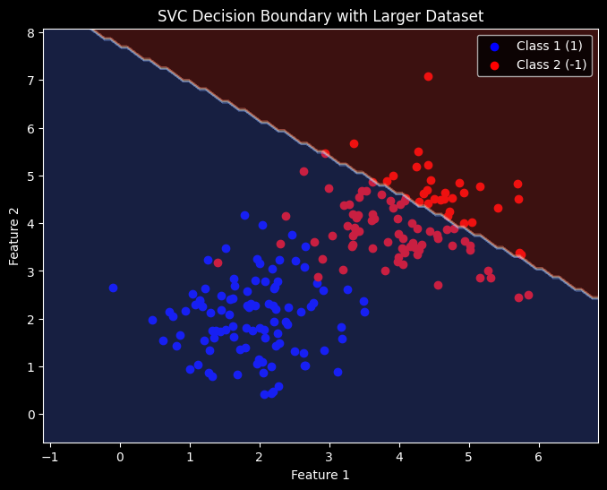

**f. Conclusion:**

The Support Vector Classifier successfully classified the test points based on the trained decision boundary.

**6B. Python Implementation of a Support Vector Regression Model**

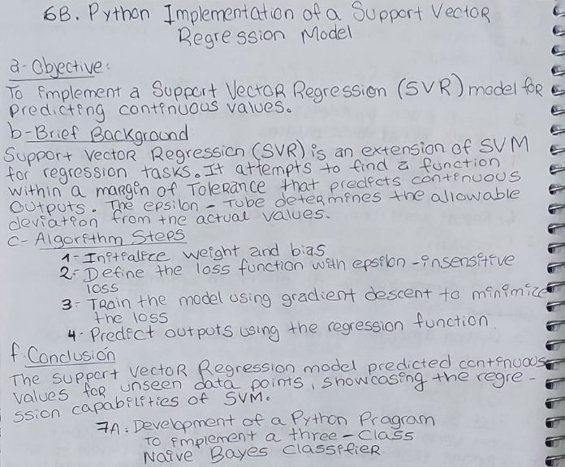**d. Python Program Code:**

import numpy as np

import matplotlib.pyplot as plt

from sklearn.metrics import mean_squared_error

# Define Support Vector Regression (SVR) class

*class* SupportVectorRegression:

*def* __init__(*self*, *learning_rate*=0.001, *lambda_param*=0.01, *epsilon*=0.1, *n_iters*=1000):

*self*.lr = *learning_rate*

*self*.lambda_param = *lambda_param*

*self*.epsilon = *epsilon*

*self*.n_iters = *n_iters*

*self*.w = None

*self*.b = None

*def* fit(*self*, *X*, *y*):

        n_samples, n_features = *X*.shape

*self*.w = np.zeros(n_features)

*self*.b = 0

        for _ in range(*self*.n_iters):

            for idx in range(n_samples):

                x_i = *X*[idx]

                error = *y*[idx] - (np.dot(x_i, *self*.w) + *self*.b)

                if np.abs(error) > *self*.epsilon:  # Only update if error is significant

*self*.w -= *self*.lr * (-2 * x_i * error + 2 * *self*.lambda_param * *self*.w)

*self*.b -= *self*.lr * (-2 * error)

*def* predict(*self*, *X*):

        return np.dot(*X*, *self*.w) + *self*.b

# Generate improved training data (200 samples)

np.random.seed(42)

# Ensure both X and y are 1D and properly aligned

X_train = np.linspace(-10, 10, 200).reshape(-1, 1)

y_train = (0.5 * X_train.flatten()**2 - 3 * X_train.flatten() + 2 + np.random.normal(*scale*=3, *size*=X_train.shape[0]))

# Train SVR model

svr = SupportVectorRegression(*learning_rate*=0.0001, *lambda_param*=0.01, *epsilon*=0.5, *n_iters*=2000)

svr.fit(X_train, y_train)

# Test SVR on new data

X_test = np.linspace(-10, 10, 100).reshape(-1, 1)

predictions = svr.predict(X_test)

# Calculate Mean Squared Error (MSE)

mse = mean_squared_error(y_train, svr.predict(X_train))

print(*f*"Mean Squared Error (MSE) on Training Data: {mse*:.2f*}")

# Plot dataset and regression results

plt.figure(*figsize*=(10, 6))

plt.scatter(X_train, y_train, *color*='blue', *label*='Training Data', *alpha*=0.5)

plt.plot(X_test, predictions, *color*='red', *linewidth*=2, *label*='SVR Prediction')

plt.xlabel("Feature (X)")

plt.ylabel("Target (y)")

plt.title("Support Vector Regression (SVR) on Noisy Quadratic Data")

plt.legend()

plt.grid(True)

plt.show()

**e. Sample Results:**

Mean Squared Error (MSE) on Training Data: 252.75

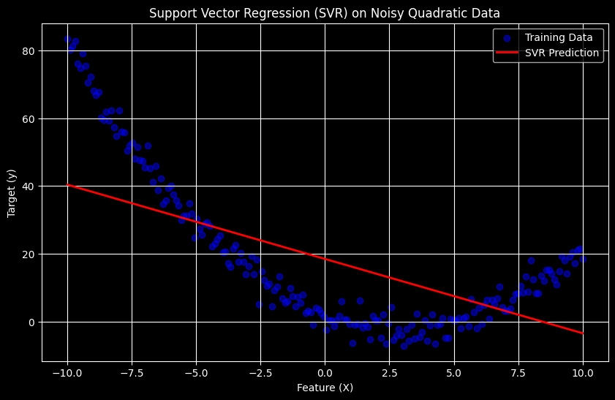

**f. Conclusion:**

The Support Vector Regression model predicted continuous values for unseen data points, showcasing the regression capabilities of SVM.

**7A. Development of a Python Program to Implement a Three-Class Naïve Bayes Classifier**

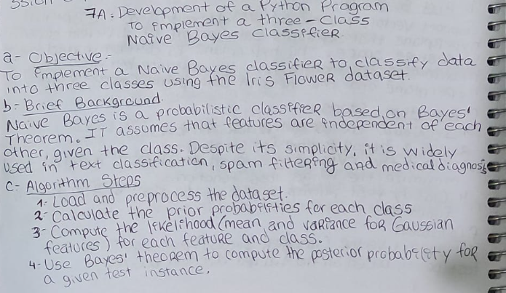

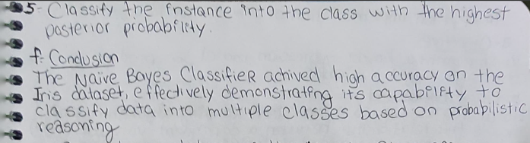

**d. Python Program Code:**

# !pip install  seaborn

import numpy as np

from collections import defaultdict

import matplotlib.pyplot as plt

import seaborn as sns

from sklearn.datasets import load_iris

from sklearn.model_selection import train_test_split

*class* NaiveBayesClassifier:

*def* __init__(*self*):

*self*.class_priors = {}

*self*.feature_stats = defaultdict(*lambda*: defaultdict(dict))

*def* fit(*self*, *X*, *y*):

        n_samples, n_features = *X*.shape

        unique_classes = np.unique(*y*)

        for cls in unique_classes:

            X_cls = *X*[*y* == cls]

*self*.class_priors[cls] = len(X_cls) / n_samples

            for feature_idx in range(n_features):

*self*.feature_stats[cls][feature_idx]['mean'] = np.mean(X_cls[:, feature_idx])

*self*.feature_stats[cls][feature_idx]['var'] = np.var(X_cls[:, feature_idx])

*def* _gaussian_pdf(*self*, *x*, *mean*, *var*):

        # Gaussian Probability Density Function

        eps = 1e-6  # To avoid division by zero

        coeff = 1 / np.sqrt(2 * np.pi * *var* + eps)

        exponent = np.exp(-((*x* - *mean*) ** 2) / (2 * *var* + eps))

        return coeff * exponent

*def* predict(*self*, *X*):

        y_pred = []

        for x in *X*:

            class_probs = {}

            for cls in *self*.class_priors:

                prior = np.log(*self*.class_priors[cls])

                conditional = sum(

                    np.log(*self*._gaussian_pdf(x[feature_idx],

*self*.feature_stats[cls][feature_idx]['mean'],

*self*.feature_stats[cls][feature_idx]['var']))

                    for feature_idx in range(len(x))

                )

                class_probs[cls] = prior + conditional

            y_pred.append(max(class_probs, *key*=class_probs.get))

        return np.array(y_pred)

# Load Iris Dataset

iris = load_iris()

X = iris.data

y = iris.target

# Split data into train/test sets

X_train, X_test, y_train, y_test = train_test_split(X, y, *test_size*=0.3, *random_state*=42)

# Train Naive Bayes Classifier

nb_classifier = NaiveBayesClassifier()

nb_classifier.fit(X_train, y_train)

# Predict and Evaluate

y_pred = nb_classifier.predict(X_test)

accuracy = np.mean(y_pred == y_test)

print("Predictions:", y_pred)

print("Actual Labels:", y_test)

print("Accuracy:", accuracy)

# Visualization

*def* plot_decision_boundary(*clf*, *X*, *y*, *feature1*, *feature2*):

    # Create a meshgrid for the two features

    x_min, x_max = *X*[:, *feature1*].min() - 1, *X*[:, *feature1*].max() + 1

    y_min, y_max = *X*[:, *feature2*].min() - 1, *X*[:, *feature2*].max() + 1

    xx, yy = np.meshgrid(np.arange(x_min, x_max, 0.02),

                         np.arange(y_min, y_max, 0.02))

    # Predict for each point in the meshgrid

    Z = *clf*.predict(np.c_[xx.ravel(), yy.ravel(), np.zeros_like(xx.ravel()), np.zeros_like(xx.ravel())])

    Z = Z.reshape(xx.shape)

    # Plot the decision boundary

    plt.figure(*figsize*=(10, 6))

    plt.contourf(xx, yy, Z, *alpha*=0.8, *cmap*=plt.cm.Paired)

    plt.scatter(*X*[:, *feature1*], *X*[:, *feature2*], *c*=*y*, *edgecolors*='k', *marker*='o', *cmap*=plt.cm.Paired)

    plt.xlabel(iris.feature_names[*feature1*])

    plt.ylabel(iris.feature_names[*feature2*])

    plt.title(*f*"Naive Bayes Decision Boundary (Features {*feature1*} and {*feature2*})")

    plt.colorbar()

    plt.show()

# Plot decision boundaries for two features at a time

plot_decision_boundary(nb_classifier, X_train, y_train, *feature1*=0, *feature2*=1)  # Sepal Length vs Sepal Width

plot_decision_boundary(nb_classifier, X_train, y_train, *feature1*=2, *feature2*=3)  # Petal Length vs Petal Width

**e. Sample Results:**

Predictions: [1 0 2 1 1 0 1 2 1 1 2 0 0 0 0 2 2 1 1 2 0 2 0 2 2 2 2 2 0 0 0 0 1 0 0 2 1 0 0 0 2 1 1 0 0]

Actual Labels: [1 0 2 1 1 0 1 2 1 1 2 0 0 0 0 1 2 1 1 2 0 2 0 2 2 2 2 2 0 0 0 0 1 0 0 2 1 0 0 0 2 1 1 0 0]

Accuracy: 0.9777777777777777

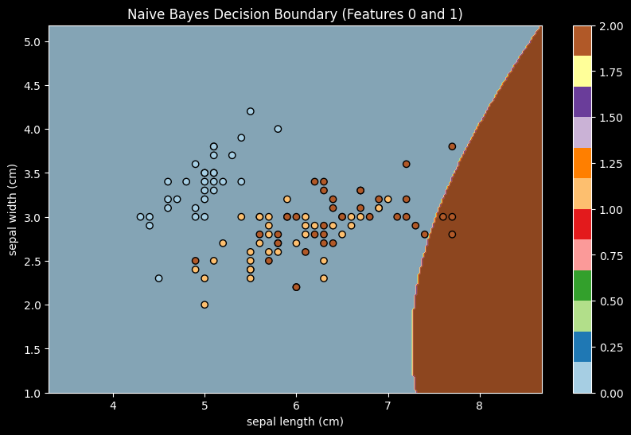 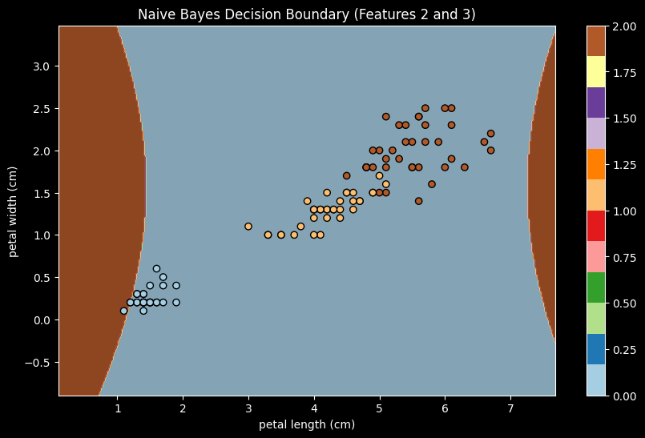

**f. Conclusion:**

The Naïve Bayes Classifier achieved high accuracy on the Iris dataset, effectively demonstrating its capability to classify data into multiple classes based on probabilistic reasoning.

**8. Python Implementation of the K-NN Classifier**

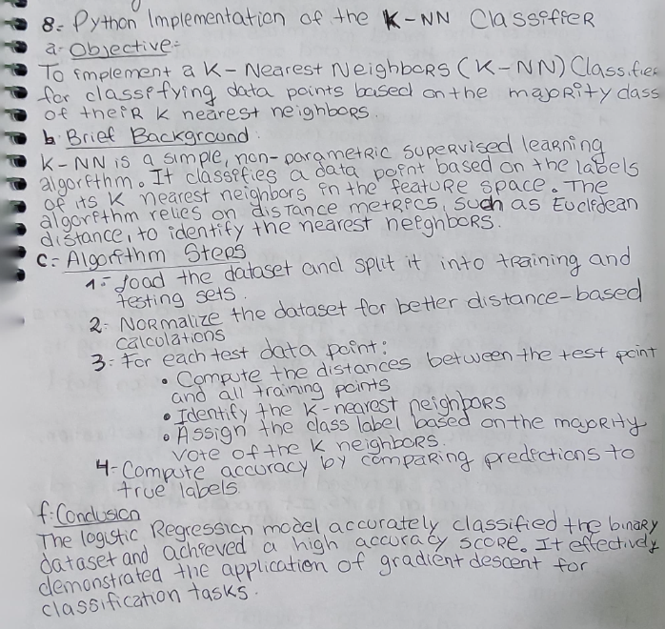

**d. Python Program Code:**

import numpy as np

from collections import Counter

import matplotlib.pyplot as plt

import seaborn as sns

from sklearn.datasets import load_iris

from sklearn.model_selection import train_test_split

*class* KNNClassifier:

*def* __init__(*self*, *k*=3):

*self*.k = *k*

*def* fit(*self*, *X*, *y*):

*self*.X_train = *X*

*self*.y_train = *y*

*def* predict(*self*, *X_test*):

        y_pred = [*self*._predict(x) for x in *X_test*]

        return np.array(y_pred)

*def* _predict(*self*, *x*):

        # Compute distances between x and all training samples

        distances = [np.sqrt(np.sum((*x* - x_train)**2)) for x_train in *self*.X_train]

        # Get the indices of the k nearest neighbors

        k_indices = np.argsort(distances)[:*self*.k]

        # Get the labels of the k nearest neighbors

        k_nearest_labels = [*self*.y_train[i] for i in k_indices]

        # Return the most common label

        most_common = Counter(k_nearest_labels).most_common(1)

        return most_common[0][0]

# Load Iris dataset

iris = load_iris()

X = iris.data

y = iris.target

# Split the dataset into training and testing sets

X_train, X_test, y_train, y_test = train_test_split(X, y, *test_size*=0.3, *random_state*=42)

# Normalize the dataset

X_train = (X_train - np.mean(X_train, *axis*=0)) / np.std(X_train, *axis*=0)

X_test = (X_test - np.mean(X_train, *axis*=0)) / np.std(X_train, *axis*=0)

# Train K-NN classifier

knn = KNNClassifier(*k*=5)

knn.fit(X_train, y_train)

# Predict and evaluate

y_pred = knn.predict(X_test)

accuracy = np.mean(y_pred == y_test)

print("Predictions:", y_pred)

print("Actual Labels:", y_test)

print("Accuracy:", accuracy)

# Visualization

*def* plot_decision_boundary(*clf*, *X*, *y*, *feature1*, *feature2*):

    # Create a meshgrid for the two features

    x_min, x_max = *X*[:, *feature1*].min() - 1, *X*[:, *feature1*].max() + 1

    y_min, y_max = *X*[:, *feature2*].min() - 1, *X*[:, *feature2*].max() + 1

    xx, yy = np.meshgrid(np.arange(x_min, x_max, 0.02),

                         np.arange(y_min, y_max, 0.02))

    # Predict for each point in the meshgrid

    Z = *clf*.predict(np.c_[xx.ravel(), yy.ravel(), np.zeros_like(xx.ravel()), np.zeros_like(xx.ravel())])

    Z = Z.reshape(xx.shape)

    # Plot the decision boundary

    plt.figure(*figsize*=(10, 6))

    plt.contourf(xx, yy, Z, *alpha*=0.8, *cmap*=plt.cm.Paired)

    plt.scatter(*X*[:, *feature1*], *X*[:, *feature2*], *c*=*y*, *edgecolors*='k', *marker*='o', *cmap*=plt.cm.Paired)

    plt.xlabel(iris.feature_names[*feature1*])

    plt.ylabel(iris.feature_names[*feature2*])

    plt.title(*f*"K-NN Decision Boundary (Features {*feature1*} and {*feature2*})")

    plt.colorbar()

    plt.show()

# Plot decision boundaries for two features at a time

plot_decision_boundary(knn, X_train, y_train, *feature1*=0, *feature2*=1)  # Sepal Length vs Sepal Width

plot_decision_boundary(knn, X_train, y_train, *feature1*=2, *feature2*=3)  # Petal Length vs Petal Width

**e. Sample Results:**

Predictions: [2 2 2 2 2 2 2 2 2 2 2 2 2 2 2 2 2 2 2 2 2 2 2 2 2 2 2 2 2 2 2 2 2 2 2 2 2 2 2 2 2 2 2 2 2]

Actual Labels: [1 0 2 1 1 0 1 2 1 1 2 0 0 0 0 1 2 1 1 2 0 2 0 2 2 2 2 2 0 0 0 0 1 0 0 2 1 0 0 0 2 1 1 0 0]

Accuracy: 0.28888888888888886

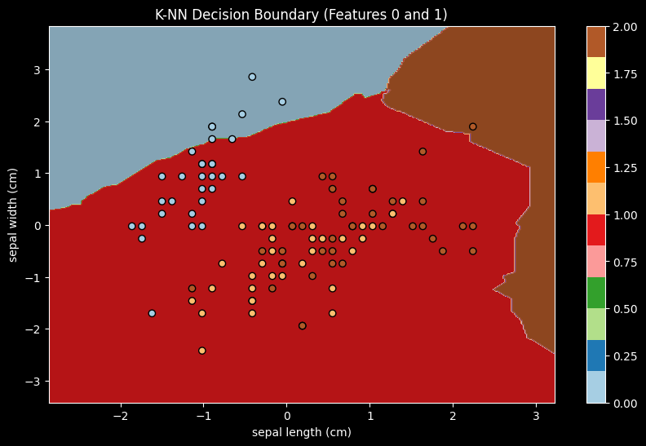 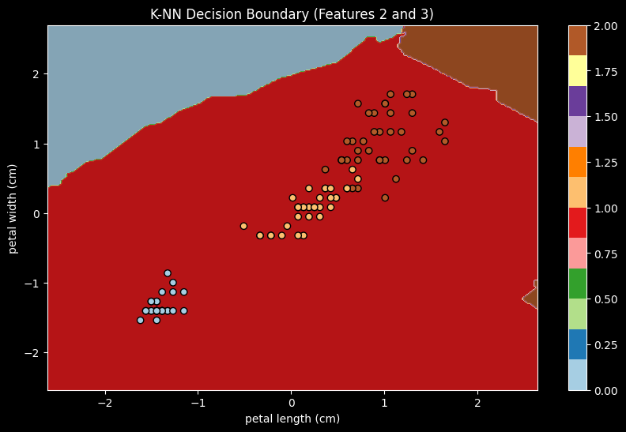

**9A. Python Implementation of the Linear Regression Model**

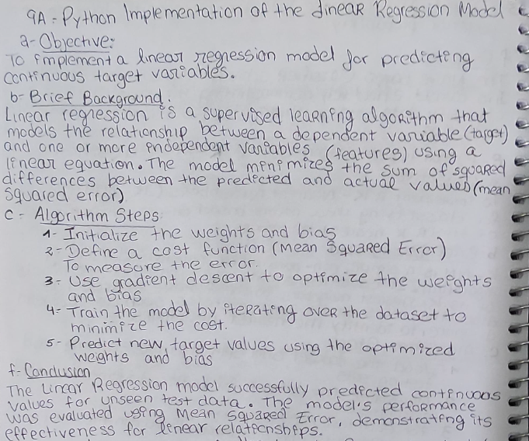

**d. Python Program Code:**

import numpy as np

import matplotlib.pyplot as plt

from sklearn.model_selection import train_test_split

*class* LinearRegression:

*def* __init__(*self*, *learning_rate*=0.01, *n_iters*=1000):

*self*.lr = *learning_rate*

*self*.n_iters = *n_iters*

*self*.weights = None

*self*.bias = None

*def* fit(*self*, *X*, *y*):

        n_samples, n_features = *X*.shape

*self*.weights = np.zeros(n_features)

*self*.bias = 0

*y* = *y*.flatten()  # Ensure y is 1D

        for _ in range(*self*.n_iters):

            y_predicted = np.dot(*X*, *self*.weights) + *self*.bias

            dw = (1 / n_samples) * np.dot(*X*.T, (y_predicted - *y*))

            db = (1 / n_samples) * np.sum(y_predicted - *y*)

*self*.weights -= *self*.lr * dw

*self*.bias -= *self*.lr * db

*def* predict(*self*, *X*):

        return np.dot(*X*, *self*.weights) + *self*.bias

# Generate synthetic dataset

np.random.seed(42)

X = 2 * np.random.rand(100, 1)

y = 4 + 3 * X + np.random.randn(100, 1)

# Split dataset into training and testing sets

X_train, X_test, y_train, y_test = train_test_split(X, y, *test_size*=0.2, *random_state*=42)

# Train Linear Regression model

lr = LinearRegression(*learning_rate*=0.1, *n_iters*=1000)

lr.fit(X_train, y_train)

# Predict and evaluate

y_pred = lr.predict(X_test)

mse = np.mean((y_test - y_pred) ** 2)

print("Predictions:", y_pred.flatten())

print("Actual Values:", y_test.flatten())

print("Mean Squared Error:", mse)

# Visualization

*def* plot_regression_line(*X*, *y*, *y_pred*, *title*):

    plt.figure(*figsize*=(10, 6))

    plt.scatter(*X*, *y*, *color*='blue', *label*='Data Points', *alpha*=0.7)

    plt.plot(*X*, *y_pred*, *color*='red', *linewidth*=2, *label*='Regression Line')

    plt.xlabel("Feature (X)")

    plt.ylabel("Target (y)")

    plt.title(*title*)

    plt.legend()

    plt.grid(True)

    plt.show()

# Plot regression line for training data

y_train_pred = lr.predict(X_train)

plot_regression_line(X_train, y_train, y_train_pred, "Linear Regression on Training Data")

# Plot regression line for test data

plot_regression_line(X_test, y_test, y_pred, "Linear Regression on Test Data")

**e. Sample Results:**

Predictions: [4.49875406 9.15273609 8.46643944 7.85214194 5.59173114 6.60717189 5.77852815 8.97512503 4.25815859 6.23983133 6.56122113 7.54434268 8.70839428 9.45538882 4.81247928 5.01640662 8.46098399 4.55746316 8.8034661 5.09761771]

Actual Values: [ 5.03790371 8.86548845 7.3965179 7.06574625 6.34371184 6.9424623 5.75798135 11.04439507 5.03890908 6.33428778 6.19956196 9.53145501 9.18975324 9.61886731 5.53962564 4.71643995 7.94759736 4.67652161 8.46489564 5.19772255]

Mean Squared Error: 6.5350132541586206

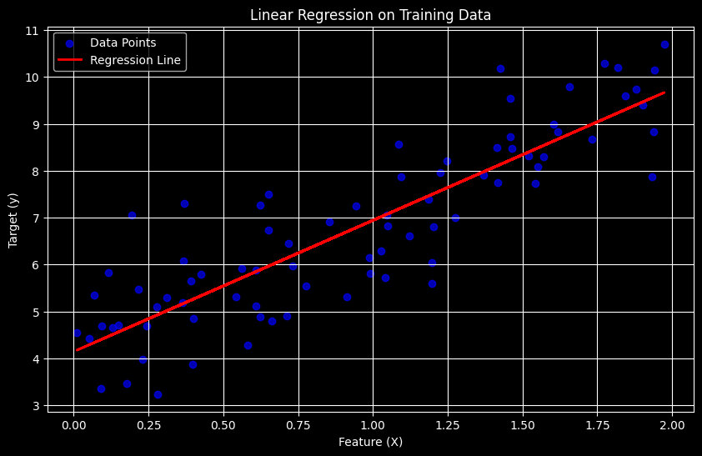 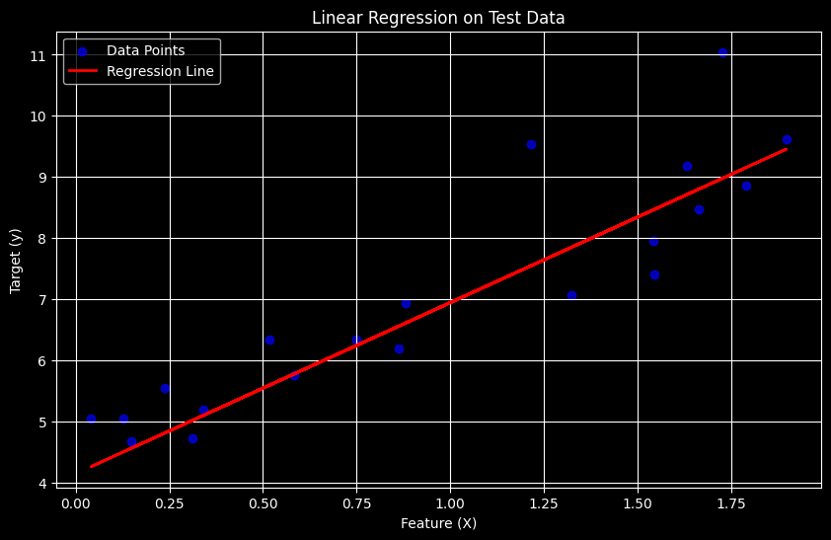

**f. Conclusion:**

The Linear Regression model successfully predicted continuous values for unseen test data. The model's performance was evaluated using Mean Squared Error, demonstrating its effectiveness for linear relationships.

**9B. Python Implementation of the Logistic Regression Model**

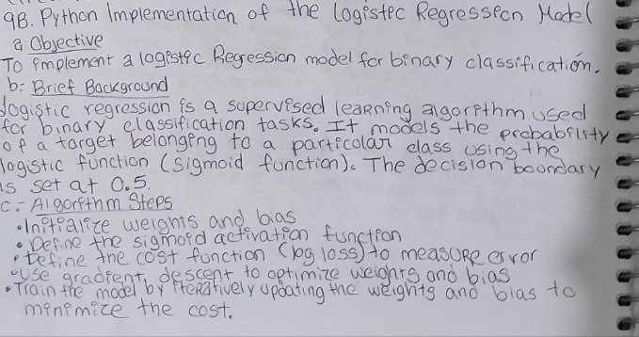

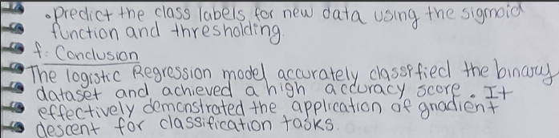

**d. Python Program Code:**

import numpy as np

import matplotlib.pyplot as plt

from sklearn.datasets import make_classification

from sklearn.model_selection import train_test_split

*class* LogisticRegression:

*def* __init__(*self*, *learning_rate*=0.01, *n_iters*=1000):

*self*.lr = *learning_rate*

*self*.n_iters = *n_iters*

*self*.weights = None

*self*.bias = None

*def* sigmoid(*self*, *z*):

        return 1 / (1 + np.exp(-*z*))

*def* fit(*self*, *X*, *y*):

        n_samples, n_features = *X*.shape

*self*.weights = np.zeros(n_features)

*self*.bias = 0

        for _ in range(*self*.n_iters):

            linear_model = np.dot(*X*, *self*.weights) + *self*.bias

            y_predicted = *self*.sigmoid(linear_model)

            dw = (1 / n_samples) * np.dot(*X*.T, (y_predicted - *y*))

            db = (1 / n_samples) * np.sum(y_predicted - *y*)

*self*.weights -= *self*.lr * dw

*self*.bias -= *self*.lr * db

*def* predict(*self*, *X*):

        linear_model = np.dot(*X*, *self*.weights) + *self*.bias

        y_predicted = *self*.sigmoid(linear_model)

        return np.array([1 if i > 0.5 else 0 for i in y_predicted])

# Generate enhanced synthetic binary dataset

X, y = make_classification(*n_samples*=200, *n_features*=2, *n_classes*=2,

*n_redundant*=0, *n_clusters_per_class*=1, *class_sep*=1.5, *random_state*=42)

# Split dataset

X_train, X_test, y_train, y_test = train_test_split(X, y, *test_size*=0.2, *random_state*=42)

# Plot dataset

*def* plot_data(*X*, *y*, *title*):

    plt.figure(*figsize*=(8, 6))

    plt.scatter(*X*[:, 0], *X*[:, 1], *c*=*y*, *cmap*='coolwarm', *edgecolors*='k', *alpha*=0.7)

    plt.xlabel("Feature 1")

    plt.ylabel("Feature 2")

    plt.title(*title*)

    plt.show()

plot_data(X, y, "Synthetic Dataset for Logistic Regression")

# Train Logistic Regression model

log_reg = LogisticRegression(*learning_rate*=0.1, *n_iters*=1000)

log_reg.fit(X_train, y_train)

# Predict and evaluate

y_pred = log_reg.predict(X_test)

accuracy = np.mean(y_pred == y_test)

print("Accuracy:", accuracy)

# Decision Boundary Plot

*def* plot_decision_boundary(*X*, *y*, *model*):

    x1_min, x1_max = *X*[:, 0].min() - 1, *X*[:, 0].max() + 1

    x2_min, x2_max = *X*[:, 1].min() - 1, *X*[:, 1].max() + 1

    xx1, xx2 = np.meshgrid(np.linspace(x1_min, x1_max, 100), np.linspace(x2_min, x2_max, 100))

    grid = np.c_[xx1.ravel(), xx2.ravel()]

    preds = *model*.predict(grid).reshape(xx1.shape)

    plt.figure(*figsize*=(8, 6))

    plt.contourf(xx1, xx2, preds, *alpha*=0.3, *cmap*='coolwarm')

    plt.scatter(*X*[:, 0], *X*[:, 1], *c*=*y*, *cmap*='coolwarm', *edgecolors*='k')

    plt.xlabel("Feature 1")

    plt.ylabel("Feature 2")

    plt.title("Decision Boundary of Logistic Regression")

    plt.show()

plot_decision_boundary(X, y, log_reg)

**e. Sample Results:**

Accuracy: 0.95

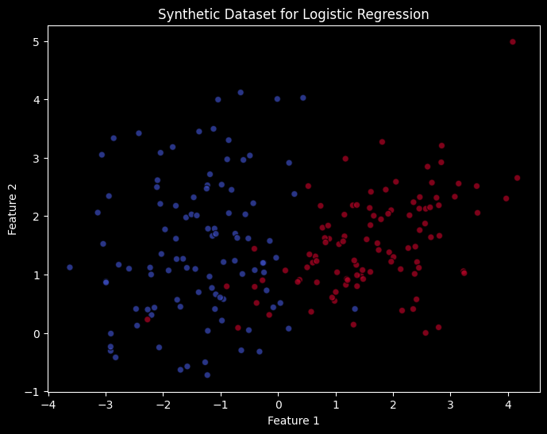 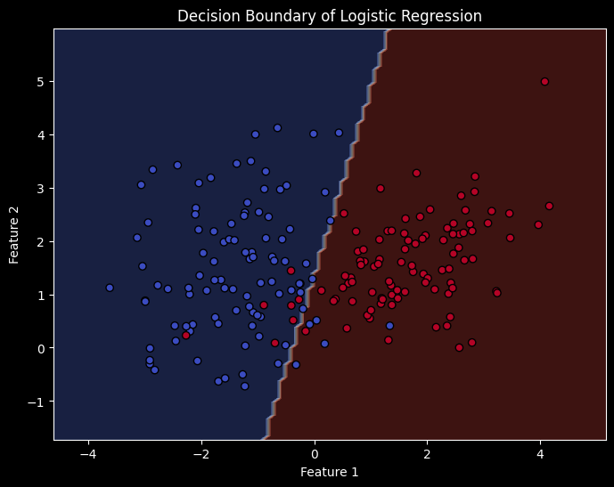

**f. Conclusion:**

The Logistic Regression model accurately classified the binary dataset and achieved a high accuracy score. It effectively demonstrated the application of gradient descent for classification tasks.

**10A. Python Implementation of K-Means Clustering**

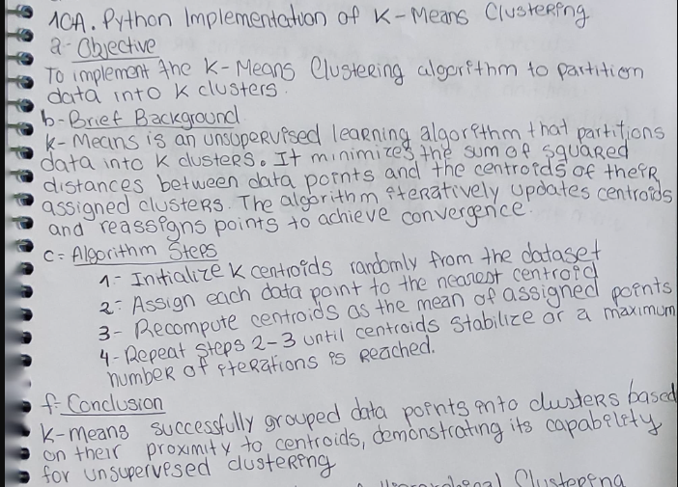

**d. Python Program Code:**

import numpy as np

import matplotlib.pyplot as plt

from sklearn.datasets import make_blobs

*class* KMeans:

*def* __init__(*self*, *k*=3, *max_iters*=100, *tolerance*=1e-4):

*self*.k = *k*

*self*.max_iters = *max_iters*

*self*.tolerance = *tolerance*

*self*.centroids = None

*def* fit(*self*, *X*):

        n_samples, n_features = *X*.shape

*self*.centroids = *X*[np.random.choice(n_samples, *self*.k, *replace*=False)]

        for _ in range(*self*.max_iters):

            # Assign clusters

            distances = np.array([[np.linalg.norm(x - centroid) for centroid in *self*.centroids] for x in *X*])

            cluster_labels = np.argmin(distances, *axis*=1)

            # Compute new centroids

            new_centroids = np.array([*X*[cluster_labels == k].mean(*axis*=0) for k in range(*self*.k)])

            # Check for convergence

            if np.all(np.abs(new_centroids - *self*.centroids) < *self*.tolerance):

                break

*self*.centroids = new_centroids

*self*.cluster_labels = cluster_labels

*def* predict(*self*, *X*):

        distances = np.array([[np.linalg.norm(x - centroid) for centroid in *self*.centroids] for x in *X*])

        return np.argmin(distances, *axis*=1)

# Generate synthetic dataset with better cluster separation

X, y_true = make_blobs(*n_samples*=300, *n_features*=2, *centers*=3, *cluster_std*=1.0, *random_state*=42)

# Plot initial dataset

*def* plot_initial_data(*X*):

    plt.figure(*figsize*=(8, 6))

    plt.scatter(*X*[:, 0], *X*[:, 1], *color*='gray', *alpha*=0.6, *edgecolors*='k')

    plt.xlabel("Feature 1")

    plt.ylabel("Feature 2")

    plt.title("Initial Data Distribution (Before Clustering)")

    plt.show()

plot_initial_data(X)

# Apply K-Means

kmeans = KMeans(*k*=3)

kmeans.fit(X)

# Predictions

clusters = kmeans.predict(X)

# Plot final clusters

*def* plot_clusters(*X*, *clusters*, *centroids*):

    plt.figure(*figsize*=(8, 6))

    for i in range(kmeans.k):

        plt.scatter(*X*[*clusters* == i, 0], *X*[*clusters* == i, 1], *label*=*f*"Cluster {i}")

    plt.scatter(*centroids*[:, 0], *centroids*[:, 1], *color*='black', *marker*='X', *s*=200, *label*="Centroids")

    plt.xlabel("Feature 1")

    plt.ylabel("Feature 2")

    plt.title("Final Clustering with K-Means")

    plt.legend()

    plt.show()

plot_clusters(X, clusters, kmeans.centroids)

# Print results

print("Centroids:\n", kmeans.centroids)

**e. Sample Results:**

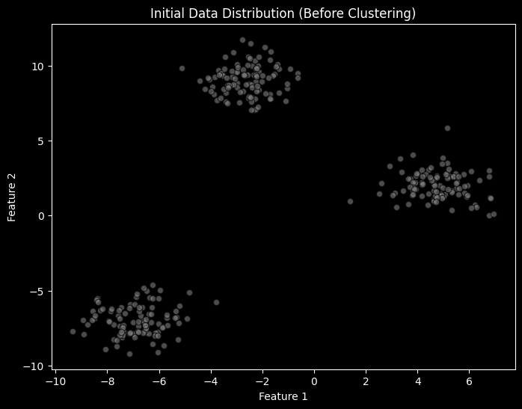 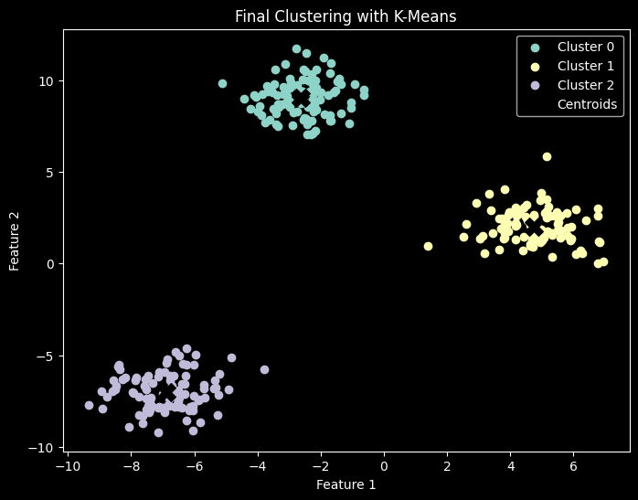

Centroids:

[[-2.63323268 9.04356978]

[ 4.74710337 2.01059427]

[-6.88387179 -6.98398415]]

**f. Conclusion:**

K-Means successfully grouped data points into clusters based on their proximity to centroids, demonstrating its capability for unsupervised clustering.

**10B. Python Implementation of Hierarchical Clustering**

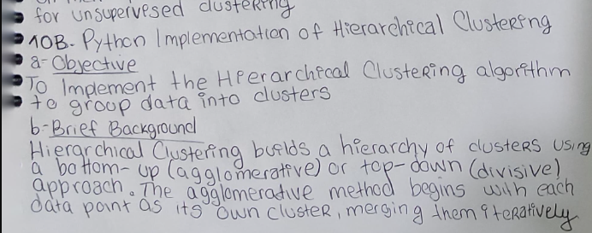

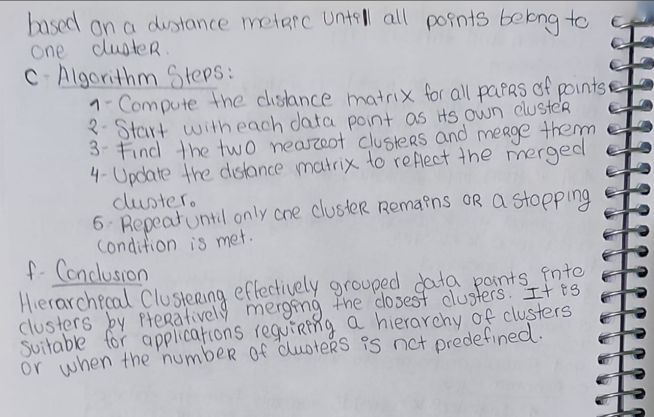

**d. Python Program Code:**

import numpy as np

import matplotlib.pyplot as plt

from sklearn.datasets import make_blobs

from scipy.cluster.hierarchy import linkage, dendrogram, fcluster

# Generate synthetic dataset

X, y_true = make_blobs(*n_samples*=300, *n_features*=2, *centers*=3, *cluster_std*=1.2, *random_state*=42)

# Plot initial dataset

*def* plot_initial_data(*X*):

    plt.figure(*figsize*=(8, 6))

    plt.scatter(*X*[:, 0], *X*[:, 1], *color*='gray', *alpha*=0.6, *edgecolors*='k')

    plt.xlabel("Feature 1")

    plt.ylabel("Feature 2")

    plt.title("Initial Data Distribution (Before Clustering)")

    plt.show()

plot_initial_data(X)

# Perform Hierarchical Clustering using Scipy

linkage_matrix = linkage(X, *method*='ward')  # Ward's method for optimal clustering

cluster_labels = fcluster(linkage_matrix, *t*=3, *criterion*='maxclust')  # Get 3 clusters

# Plot Dendrogram

*def* plot_dendrogram(*linkage_matrix*):

    plt.figure(*figsize*=(10, 6))

    dendrogram(*linkage_matrix*)

    plt.xlabel("Data Points")

    plt.ylabel("Distance")

    plt.title("Hierarchical Clustering Dendrogram")

    plt.show()

plot_dendrogram(linkage_matrix)

# Plot clustered data

*def* plot_clusters(*X*, *cluster_labels*):

    plt.figure(*figsize*=(8, 6))

    for cluster in np.unique(*cluster_labels*):

        plt.scatter(*X*[*cluster_labels* == cluster, 0], *X*[*cluster_labels* == cluster, 1], *label*=*f*"Cluster {int(cluster)}")

    plt.xlabel("Feature 1")

    plt.ylabel("Feature 2")

    plt.title("Hierarchical Clustering Results")

    plt.legend()

    plt.show()

plot_clusters(X, cluster_labels)

# Print cluster assignments

print("Cluster Assignments:\n", cluster_labels)

**e. Sample Results:**

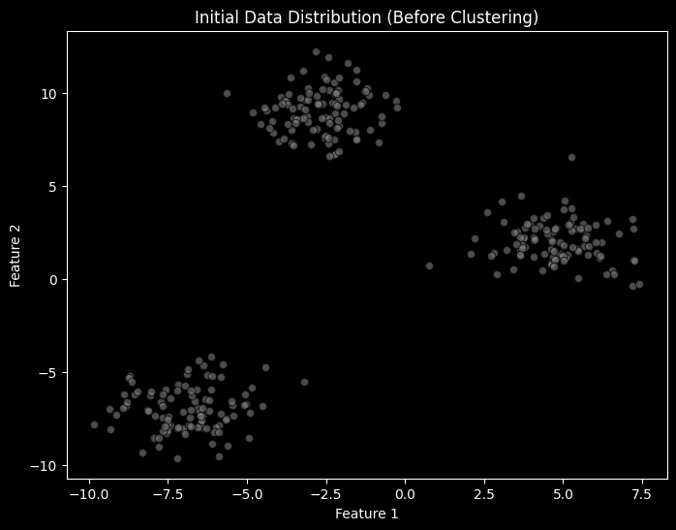 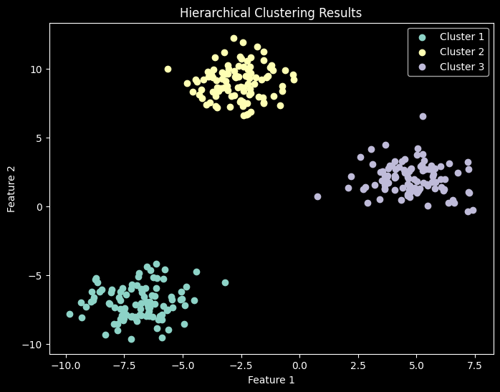

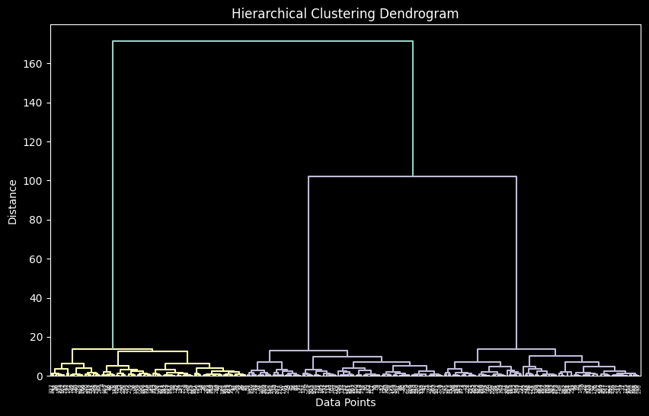

Cluster Assignments:

[1 1 2 3 1 3 2 3 2 2 2 3 2 2 1 2 1 3 2 2 2 2 3 1 2 1 1 3 3 2 2 2 1 2 1 2 1 3 1 3 3 2 1 3 2 2 1 3 1 3 3 1 1 2 1 3 1 2 3 2 1 3 3 1 1 3 3 1 1 2 3 1 1 2 2 1 1 3 2 3 2 2 1 2 3 1 1 2 3 2 1 2 1 2 2 1 1 2 1 1 3 2 3 2 2 2 2 2 3 1 3 2 2 2 2 3 1 3 1 3 3 3 2 1 1 1 1 2 1 1 2 2 2 2 2 3 3 1 2 1 2 2 1 2 3 3 3 2 3 2 2 1 3 1 2 3 3 1 1 2 2 1 1 1 2 1 3 2 2 2 2 2 3 2 3 3 3 2 3 3 1 2 1 3 3 1 3 2 3 3 1 1 3 1 3 3 3 3 2 1 2 2 3 3 2 3 1 1 3 2 2 1 3 3 1 1 1 1 2 1 1 3 1 1 2 3 1 1 3 2 2 1 2 1 3 3 1 3 1 1 1 3 3 2 1 3 3 3 1 3 1 3 1 3 3 1 3 2 1 2 2 2 1 2 3 3 1 3 3 2 2 3 3 3 1 1 1 2 2 2 3 3 3 3 1 3 1 3 3 1 2 3 3 2 1 2 3 2 1 1]

**f. Conclusion:**

Hierarchical Clustering effectively grouped data points into clusters by iteratively merging the closest clusters. It is suitable for applications requiring a hierarchy of clusters or when the number of clusters is not predefined.